What should you do??
- You get to a traffic light and it is flashing red…. What should you do
- You have a green light at an intersection. However you notice a pedestrian is crossing with a red do not walk…… what should you do
- You are out for a drive and it starts to rain…. What should you do
- You are out for a drive and notice a horse and rider on the side of the road.. what should you do
- A vehicle has just parked on main street in Littleton, what can you expect to happen next
- You are at a solid red traffic light…. What should you do
- You are at a traffic light and the light has a solid green, below it is a red arrow pointing to the left. You want to go left…. What should you do
- You are driving on a highway with multiple lanes. The lanes are painted a solid white….what should you do
- If your vehicle starts to skid, sway or hydroplane…… what should you do
- Your vehicle goes off the edge of the highway …. What should you do
- If an emergency vehicle comes up behind you, and the traffic is heavy….what should you do
- When you are driving at night, you see a vehicle coming toward you… what should you do
- 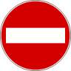what does this sign mean
- What does this sign mean
- What does this sign mean
- What does this sign mean
- What does this sign mean
- 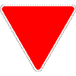What does this sign mean
- What does this sign mean
- 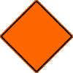What does this sign mean

